Andrew Allen

CS 499 Module One Assignment Template

Complete this template by replacing the bracketed text with the relevant information.

- Self-Introduction: Address all of the following questions to introduce yourself.

  - How long have you been in the Computer Science program?
I have been in the Computer Science program for one and half years, I began my journey January of 2025.

  - What have you learned while in the program? List three of the most important concepts or skills you have learned.
The three most important concepts or skills I have learned while in the program is critical thinking, systematic planning, and software designing.

  - Discuss the specific skills you aim to demonstrate through your enhancements to reach each of the course outcomes.
Through refactoring my artifact, I will demonstrate professional competencies in design patterns, algorithm optimization, and data layer abstraction.

To satisfy course outcome 1, I will demonstrate an awareness of stakeholders and end users of the application by designing and refactoring the artifact to ensure ease of navigation, modularity, and high legibility with a light and dark theme that adapts to user needs.

To satisfy course outcome 2, I will demonstrate high quality engineering by designing the app for the target audience, writing secure code, testing, commenting code, and writing a professional readme.

To satisfy course outcome 3, I will demonstrate computer science theory by implementing an optimized in-memory search and filtering algorithm that manages tradeoffs between RAM cache and storage disk I/O.

To satisfy course outcome 4, I will demonstrate my ability to leverage innovative tools by migrating a legacy Java codebase to a modern production ready Kotlin codebase. I will also transition the SQLite database to the Room Object Relational Mapping database, the new industry standard.

To satisfy course outcome 5, I will demonstrate a security oriented mindset by leveraging Kotlins native compile time null safety and Room Object Relational Mappings automated SQL compile time query verifications, which will eliminate runtime vulnerabilities.

  - How do the specific skills you will demonstrate align with your career plans related to your degree?
These skills align perfectly with my career plans to function as an independent software engineer that manages my own app publishing business. Launching software to commercial marketplaces requires deeper understanding of software architecture, optimization, and maintainability. Through refactoring my artifact from a legacy architecture into a modern and scalable application, I am demonstrating the skills necessary to maintain a production level codebase for years to come.

  - How does this contribute to the specialization you are targeting for your career?
My professional specialization targets native mobile app engineering and independent software development. Modern native Android ecosystems have fully standardized Kotlin as the language of choice. By re-architecting my application using Kotlin, Jetpack, and Room ORM, I am demonstrating mastery over Androids modern mobile stack. This project will showcase my capability to transform a legacy codebase into a modern, more compliant and efficient codebase for commercial production.

- ePortfolio Set Up:

  - Submit a screen capture of your ePortfolio GitHub Pages home page that clearly shows your URL.
    - You already have a repository in GitHub where you uploaded projects in previous courses. Your ePortfolio will reside in GitHub but can link to work at other sites, such as Bitbucket.

  - Use the GitHub Pages link in the Resource section for directions on:
    - How to create your GitHub website and publish code to GitHub Pages
    - Issues, such as adding links to other sites

  - Paste a screenshot of your GitHub Pages home page with your URL clearly showing in the space below.

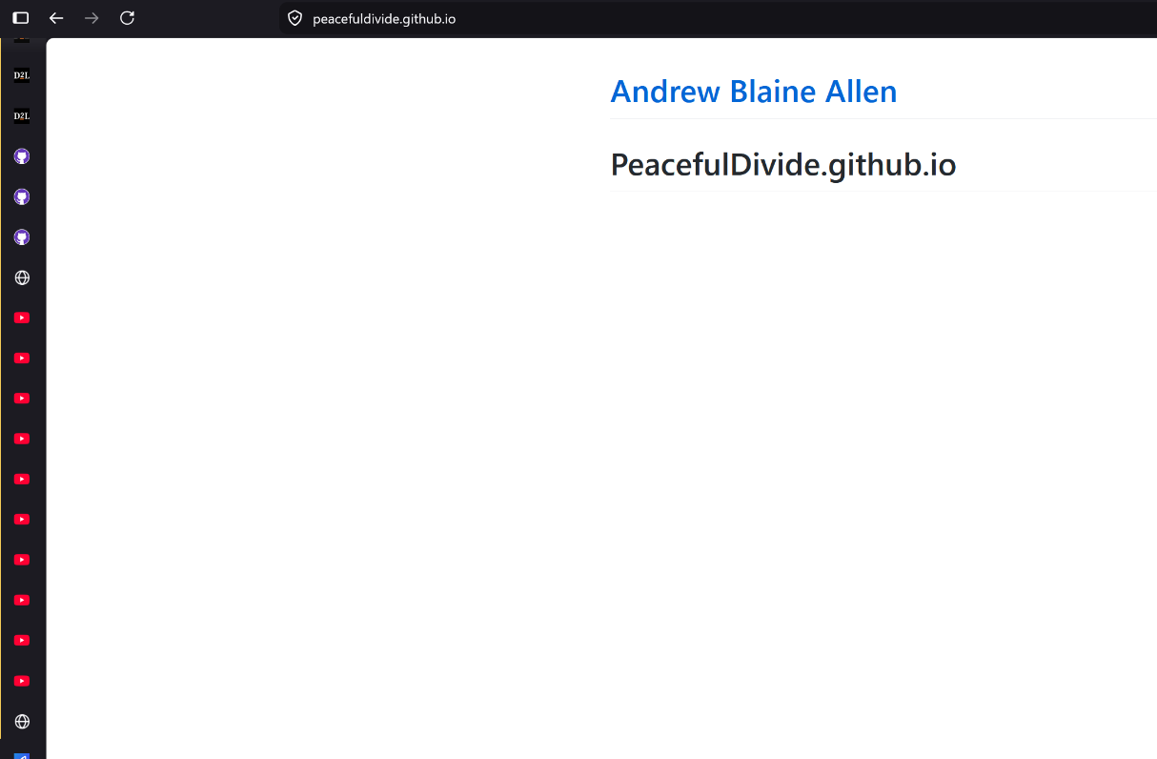

- Enhancement Plan:

  - Category One: Software Engineering and Design
    - Select an artifact that is aligned with the software engineering and design category and explain its origin. Submit a file containing the code for the artifact you choose with your enhancement plan.
I am choosing an artifact from my CS360 Mobile Architecture and Programming course, the inventory app I developed. This application was built with warehouse workers, small business owners, and collectors in mind. It offered an offline and secure solution for users to track their inventory or collections. The application was developed with Java and used the legacy MVC design pattern.

Note: Your artifact may be work from the following courses:

- IT 145: Foundation in Application Development
- CS 250: Software Development Lifecycle
- CS 260: Data Structures and Algorithms
- IT 315: Object Oriented Analysis and Design
- CS 320: Software Testing, Automation, and Quality Assurance
- CS 330: Computational Graphics and Visualization
- CS 340: Advanced Programming Concepts
- CS 350: Emerging Systems Architectures and Technologies
- CS 360: Mobile Architecture and Programming
- IT 365: Operating Environments
- IT 380: Cybersecurity and Information Assurance
- CS 405: Secure Coding
- CS 410: Reverse Software engineering
- IT 340: Network and Telecommunication Management
- IT 380: Cybersecurity and Information Assurance

    - Describe a practical, well-illustrated plan for enhancement in alignment with the category, including a pseudocode or flowchart that illustrates the planned enhancement.
I plan to enhance the application by taking it from Java and completely refactoring and migrating it to modern Kotlin standards. The current Java codebase pairs the UI with business logic inside activities, which is a major design anti-pattern. The enhancement will consist of rewriting the app in Kotlin to use native null safeties and coroutines, while also designing and building the application with the MVVM design pattern. This directly supports industry best practices by making the codebase modular and more maintainable.
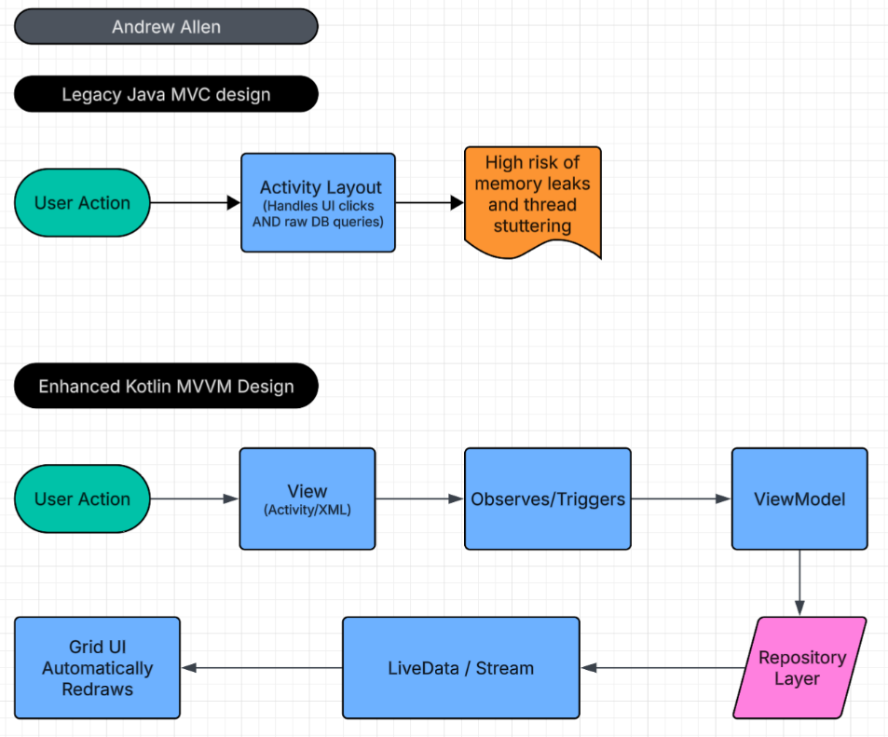
As illustrated in the architecture flowchart above, the apps structural design is being transformed from a legacy Model-View-Controller (MVC) pattern into a modern Model-View-ViewModel (MVVM) pattern.
In the legacy design, Android activities handle all app aspects simultaneously. The rendering, user clicks, and database executions. This creates a system prone to memory leaks and lockups. The enhanced MVVM design separates these layers. The view layer is restricted to UI rendering. When a user interacts with the UI, the event is passed to the lifecycle aware ViewModel, which accesses the Repository layer backed by Room ORM. This means the business logic is completely separated from the UI lifecycle, maximizing the codebases maintainability, scalability, and testability.
For this category of enhancement, consider improving a piece of software, transferring a project into a different language, reverse engineering a piece of software for a different operating system, or expanding a project’s complexity. These are just recommendations. Consider being creative and proposing an alternative enhancement to your instructor.

Think about what additions to include to complete the enhancement criteria in this category. Since one example option is to port to a new language, that is the kind of scale that is expected. This does not mean you need to port to a new language but instead have an equivalent scale of enhancement. Underlying expectations of any enhancement include fixing errors, debugging, and cleaning up comments, but these are not enhancements themselves.

    - Explain how the planned enhancement will demonstrate specific skills and align with course outcomes.

      - Identify and describe the specific skills you will demonstrate that align with the course outcome.
This enhancement will demonstrate architectural modularization, updated design pattern implementation, and language translation. Through porting the codebase from Java to Kotlin and changing the design pattern to a more modular and maintainable one, I demonstrate skills in structural design.

      - Select one or more of the course outcomes below that your enhancement will align with.
This enhancement aligns with course outcomes two and four.

Course Outcomes:

- Employ strategies for building collaborative environments that enable diverse audiences to support organizational decision-making in the field of computer science.
- Design, develop, and deliver professional-quality oral, written, and visual communications that are coherent, technically sound, and appropriately adapted to specific audiences and contexts.
- Design and evaluate computing solutions that solve a given problem using algorithmic principles and computer science practices and standards appropriate to its solution while managing the trade-offs involved in design choices.
- Demonstrate an ability to use well-founded and innovative techniques, skills, and tools in computing practices for the purpose of implementing computer solutions that deliver value and accomplish industry-specific goals.
- Develop a security mindset that anticipates adversarial exploits in software architecture and designs to expose potential vulnerabilities, mitigate design flaws, and ensure privacy and enhanced security of data and resources.

  - Category Two: Algorithms and Data Structures

- Select an artifact that is aligned with the algorithms and data structures category and explain its origin. Submit a file containing the code for the artifact you choose with your enhancement plan. You may choose work from the courses listed under Category One.
The artifact selected is the same inventory app developed in Java during my CS360 course. In its current form, the application lacks a search mechanism, forcing users to manuallys scroll through a standard grid container to locate items, which is unintuitive.

- Describe a practical, well-illustrated plan for enhancement in alignment with the category, including a pseudocode or flowchart that illustrates the planned enhancement.
This enhancement involves planning, building, and executing an optimized search utilizing an ArrayList and filter utilizing a linear search filtering algorithm. It will be focused on minimizing bottlenecks and latency. The app will be designed to load persistent data into an active memory cache from the persistent database upon initialization. When a user inputs text in the search field, a localized filtering algorithm will process queries in the collection. While, the time complexity is O(n) for a linear scan, executing an O(n) operation in RAM takes microseconds compared to a scan on raw disk storage which causes stuttering and latency on mobile devices.
PSEUDOCODE
In memory inventory search
FUNCTION executeSearch(userInput)
// If the search box is empty, show all items.
IF userInput is empty THEN
SHOW(fullCachedList)
RETURN
END IF
// Create temporary list to hold search results
SET matchingItems = EMPTY_LIST
SET searchWord = LOWERCASE(userInput)
// Loop through every item stored in memory cache
FOR EACH item IN fullCachedList DO
// If the item’s name contains the search word, save it.
IF LOWERCASE(item.name) CONTAINS searchWord THEN
ADD item TO matchingItems
END IF
END FOR
// Send matching items to screen to update grid
SHOW(matchingItems)
END FUNCTION

For this category of enhancement, consider improving the efficiency of a project or expanding the complexity of the use of data structures and algorithms for your artifact. These are just recommendations. Consider being creative and proposing an alternative enhancement to your instructor. Note: You only need to choose one type of enhancement per category.

Think about what additions to include to complete the enhancement criteria in this category. Since one example option is to port to a new language, that is the kind of scale that is expected. Perhaps you might increase the efficiency and time complexity of an algorithm in an application and detail the logic of the increased time complexity. Remember, you do not need to port to a new language but instead have an equivalent scale of enhancement. Underlying expectations of any enhancement include fixing errors, debugging, and cleaning up comments, but these are not enhancements themselves.

- Explain how the planned enhancement will demonstrate specific skills and align with course outcomes.

  - Identify and describe the specific skills you will demonstrate to align with the course outcome.
This enhancement will demonstrate understanding of algorithmic time complexity, memory allocation trade off’s, and runtime resource optimization. It highlights my ability to evaluate data structure operations by distinguishing between volatile and persistent storage read and write speeds.

  - Select one or more of the course outcomes listed under Category One that your enhancement will align with.
This aligns with course outcome three.

  - Category Three: Databases

    - Select an artifact that is aligned with the databases category and explain its origin. Submit a file containing the code for the artifact you choose with your enhancement plan. You may choose work from the courses listed under Category One.
The selected artifact is the same inventory app developed in Java during my CS360 course. In its current state, the app uses a localized, persistent relational data structure built with the SQLite framework.

    - Describe a practical, well-illustrated plan for enhancement in alignment with the category, including a pseudocode or flowchart that illustrates the planned enhancement.
The apps storage architecture will undergo a full upgrade, migrating away from legacy SQLite operations to the Android Room Object Relational Mapping database system. This enhancement turns unstructured database interactions into strict, safe type access object mapping declarations, exposing data sets as reactive live streams. This binds the data storage layer directly to the MVVM layer so that database operations trigger instant visual UI changes.
PSEUDOCODE
Room ORM database
// Define what an Inventory Item looks like in the database table
@DatabaseTable(name = “inventory_table”)
CLASS InventoryItem (
id: INTEGER (AutoIncrement, PrimaryKey),
name: TEXT,
quantity: INTEGER,
lowStockThreshold: INTEGER
)
// Define safe database commands allowed in the app
@DatabaseCommands
INTERFACE InventoryQueries
@Insert
FUNCTION addItem(newItem: InventoryItem)
@Delete
FUNCTION deleteItem(oldItem: InventoryItem)
@Query(“SELECT * FROM inventory_table ORDER BY name ASC”)
// Automatically updates the UI when data changes
FUNCTION getAllItems() RETURNS LiveDataList
END INTERFACE

For this category of enhancement, consider adding more advanced concepts of MySQL, incorporating data mining, creating a MongoDB interface with HTML/JavaScript, or building a full stack with a different programming language for your artifact. These are just recommendations; consider being creative and proposing an alternative enhancement to your instructor. Note: You only need to choose one type of enhancement per category.

Think about what additions to include to complete the enhancement criteria in this category. Since one example option is to port to a new language, that is the kind of scale that is expected. Perhaps you might increase the efficiency and time complexity of an algorithm in an application and detail the logic of the increased time complexity. Remember, you do not need to port to a new language but instead have an equivalent scale of enhancement. Underlying expectations of any enhancement include fixing errors, debugging, and cleaning up comments, but these are not enhancements themselves.
    - Explain how the planned enhancement will demonstrate specific skills and align with course outcomes.

      - Identify and describe the specific skills you will demonstrate that align with the course outcome.
This enhancement demonstrates database modeling safety, secure abstraction encapsulation, and reactive data pipelines. Through integrating Room ORM, I showcase the capability to enforce compile time validation. This results in invalid SQL calls to fail during compilation instead of crashing completely. This also demonstrates my security oriented approach, as it protects the underlying storage schemas from query manipulation and syntax exploitation vulnerabilities.

      - Select one or more of the course outcomes listed under Category One that your enhancement will align with.
This enhancement aligns with categories four and five.

- ePortfolio Overall Skill Set

  - Accurately describe the skill set to be illustrated by the ePortfolio overall.
    - Skills and outcomes planned to be illustrated in the code review
Overall, the code review will illustrate my technical analysis, code auditing, and oral communication skills. I will walk through the codebase demonstrating my ability to evaluate a functional system objectively, pinpointing vulnerabilities, and discussing anti-patterns in MVC and SQLite.

    - Skills and outcomes planned to be illustrated in the narratives
The documentation narratives will demonstrate my skills in professional technical writing, software documentation, and design justification. Through the clear documentation of my technical choices, these narratives will establish my skill set as an analytical systems architect who builds software around requirements rather than just throwing code together.

    - Skills and outcomes planned to be illustrated in the professional self-assessment
The professional self-assessment will showcase my growth throughout the computer science program and compare it to industry expectations. It will reflect my commitment to to continuous improvement, data security principles, and engineering ethics. Ultimately, it will position me as a modern, security conscious mobile developer prepared to run an app publishing development lifecycle.

